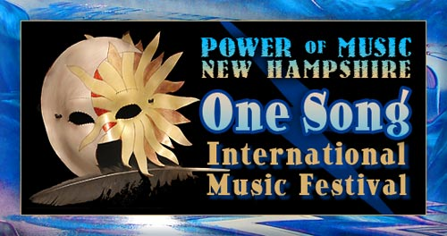
With Innovations for Humanity Summit, Exposition & Conference
powerofmusicnh.com
Event Director: B. Hughes 928-202-1447

Email form to: b@powerofmusicnh.com

Vendor Booth Application
Please refer to website for payment options
Name:
Business Name:
Phone:
Email:
Website:
Address:
Vendor Package: $100, $250 or $500
Will you need tables and chairs?
Brief Description of your Business:

